**WS15-ASSOCIATIONS-AGGREGATION**

**DATE: 07th december 2021**

1 ALMACHE LITARDO ANDERSON MOISÉS

Inspector: Altamirano Cristhian

classes: 8/10 missing classes Simulator Display, Food Pile

relationships: 6/10

Colony-Ant 1/1

Area-AntEater 1/1 (Cell-AntEater)

Area-Cell 0/1

Colony-Nest 1/1

FoodPile-Food 0/1

Ant-Food 1/1

Cell-PheromoneDrop 0/1

Area-Colony 1/1

Area-FoodPile 0/1

Simulator-Area 0/1

Ant-Pheromone 1/1 dependency

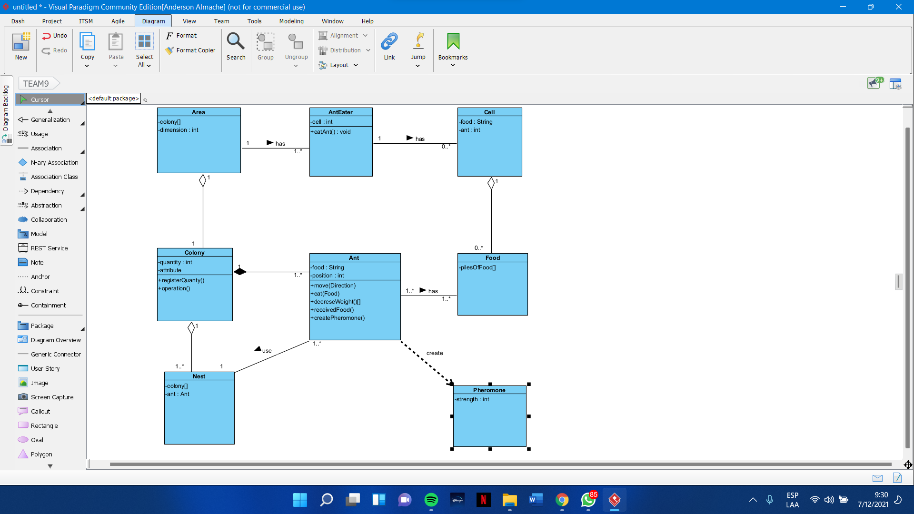

2 ALTAMIRANO BENALCAZAR CRISTHIAN ALEXANDER

Inspector: Alvarez Michelle

classes: 8/10 missing classes antEater, Main

relationships: 6/10

Colony-Ant 1/1

Area-AntEater 0/1

Area-Cell 1/1

Colony-Nest 1/1

FoodPile-Food 1/1

Ant-Food 1/1

Cell-PheromoneDrop 0/1

Area-Colony 1/1

Area-FoodPile 0/1

Simulator-Area 0/1

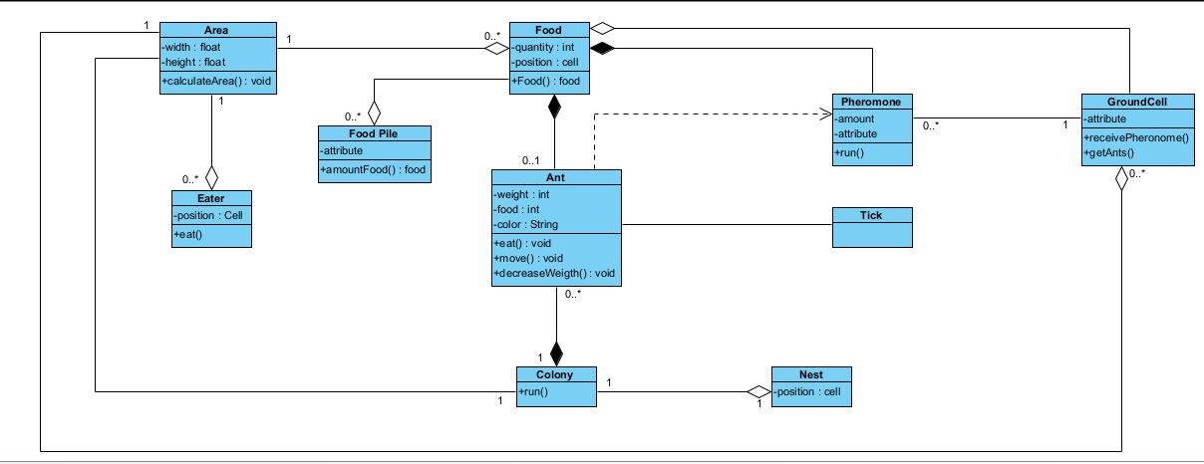

3 ALVAREZ RAMIREZ MICHELLE ESTEFANIA

Inspector: Andrade Alan

classes: 8.5/10

There aren't the class Simulator Display and AntEater

not have main and wrong name (pheromone drop)

relationships: 7,5 /10

Colony-Ant 1/1

Area-AntEater 0,5/1 (Cell-AntEater)

Area-Cell 1/1

Colony-Nest 1/1

FoodPile-Food 1/1

Ant-Food 1/1

Cell-PheromoneDrop 0,5/1

Area-Colony 1/1

Area-FoodPile 0/1

Simulator-Area 0/1

Ant-Pheromone 0,5/1 dependency

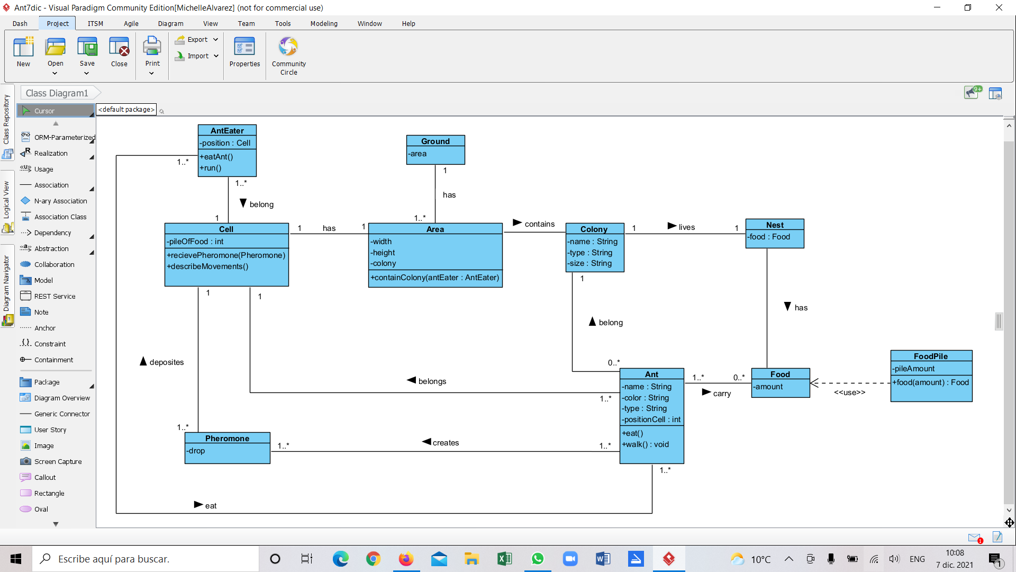

4 ANDRADE CARATE ALAN DAMIAN

Inspector: Andrango Espinosa Alex Paul

classes: 9/10 not have main and wrong name (pheromone drop)  
relationships: 7/10

1. Colony-Ant 1/1
2. Area-AntEater 1/1
3. Area-Cell 0.5/1
4. Colony-Nest 1/1
5. Food Pile-Food 0.5/1
6. Ant-Food 1/1
7. Cell-Pheromone Drop 1/1
8. Area-Colony 1/1
9. Area-Food Pile 0/1
10. Simulator-Area 0/1
11. Ant-Pheromone 0/1 dependency

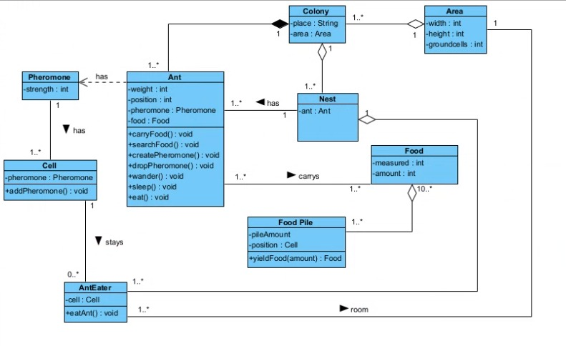

5 ANDRANGO ESPINOSA ALEX PAÚL

Inspector: Cristian Arroba

classes: 8/10 missing classes, Simulador Display, Food pile

relationships: 5/10

1. Colony-Ant 1/1
2. Area-AntEater 1/1 (Cell-AntEater)
3. Area-Cell 0/1
4. Colony-Nest 1/1
5. FoodPile-Food 0/1
6. Ant-Food 1/1
7. Cell-PheromoneDrop 0/1
8. Area-Colony 1/1
9. Area-FoodPile 0/1
10. Simulator-Area 0/1



6 ARROBA SOLORZANO CRISTIAN ALEXANDER

Inspector: Dylan Asumaza

classes: 7/10 classes simulador display ,pheromone drop, food pile

relationships: 6/10

1. Colony-Ant 1/1
2. Area-AntEater 1/1 (Cell-AntEater)
3. Area-cell 0/1
4. Colony-Nest 0/1
5. FoodPile-Food 0/1
6. Ant-Food 1/1
7. Cell-PheromoneDrop 1/1
8. Area-Colony 1/1
9. Area-FoodPile 0/1
10. simulator-Area 0/1
11. Ant-Peromone 1/1 dependency

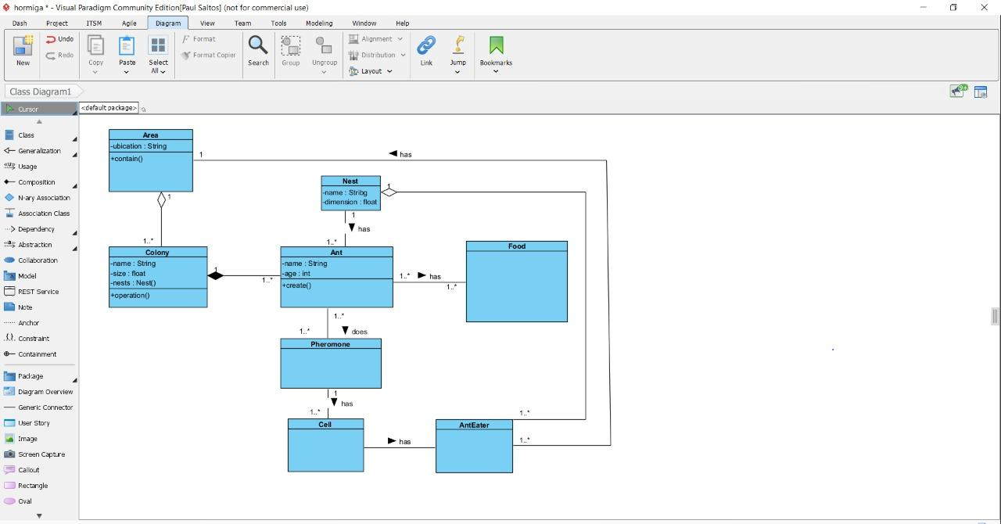

7 ASUMAZA GUALOTO DYLAN ALEXANDER

**Inspector:** Bravo Katherin

**classes:**  **8/10** There are 2 classes missing, in total there are 10.(missing FoodPile,it is recommended to put PheromoneDrop)

**relationships:**  **6/10**

**Total: 14/20**

1. Colony-Ant 1/1
2. Area-AntEater 1/1 (Cell-AntEater)
3. Area-Cell 0/1
4. Colony-Nest 1/1
5. FoodPile-Food 0/1
6. Ant-Food 1/1
7. Cell-PheromoneDrop 0/1
8. Area-Colony 1/1
9. Area-FoodPile 0/1
10. Simulator-Area 0/1
11. Ant-Pheromone 1/1 dependency



8 BRAVO RODRIGUEZ KATHERIN DAYANNE

Inspector: Christian Bravo

classes: 7/10 + 1 (classes: Direction, and Position), missing clases main, Area and AntEater

relationships: 8/10

Total 15/20

1. Colony -Ant 1/1
2. Area-AntEater 1/1
3. Area-cell 0 /1
4. Colony-Nest
5. FoodPile-Food 1/1
6. Ant-Food 1/1
7. Cell-PheromoneDrop 1 /1
8. Area-Colony 1/1
9. Area-FoodPile 0/1
10. Simulator-Area 0 /1

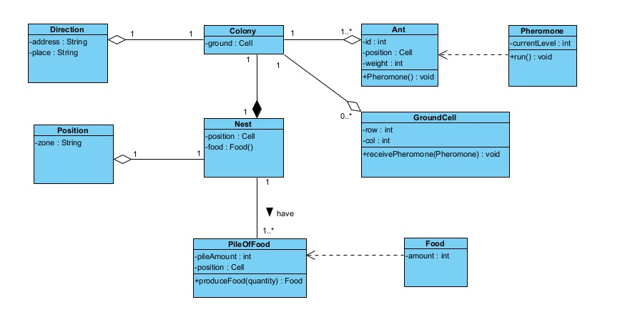

9 BRAVO VILLALOBOS CHRISTIAN DAVID

Inspector: Pablo Bustillos

classes: **8/10**(two classes are missing)

relationships: **6/10**

**Total 14/20**

colony-ant 1/1

Area-AntEater 1/1

Area-cell 0/1

colony-nest 1/1

foodPile-Food 0 /1

Ant-Food 1 /1

Cell-PheromoneDrop 1/1

Area-Colony 1/1

Area-FoodPile 0/1

Simulator-Area 0/1

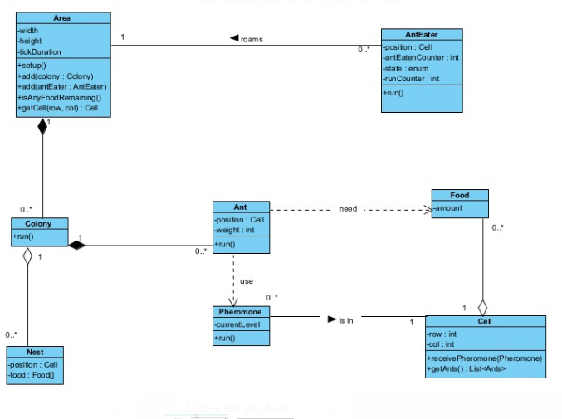

10 BUSTILLOS MONTENEGRO PABLO SEBASTIAN

Inspector:Benjamin Cadena

classes: 9/10 (missing classes Simulator Display)

relationships: 10/10

1.Colony-Ant /1

2. Area-AntEater 1/1

3. Area-Cell 1/1

4.Colony-Nest 1/1

5.FoodPile-Food 1/1

6.Ant-Food 1/1

7.Cell-PheromoneDrop 1/1

8. Area-Colony 1/1

9. Area-FoodPile 1/1

10. Simulator-Area 0/1 (there is no simulator display class)

11. Ant-Pheromone 1/1 dependency

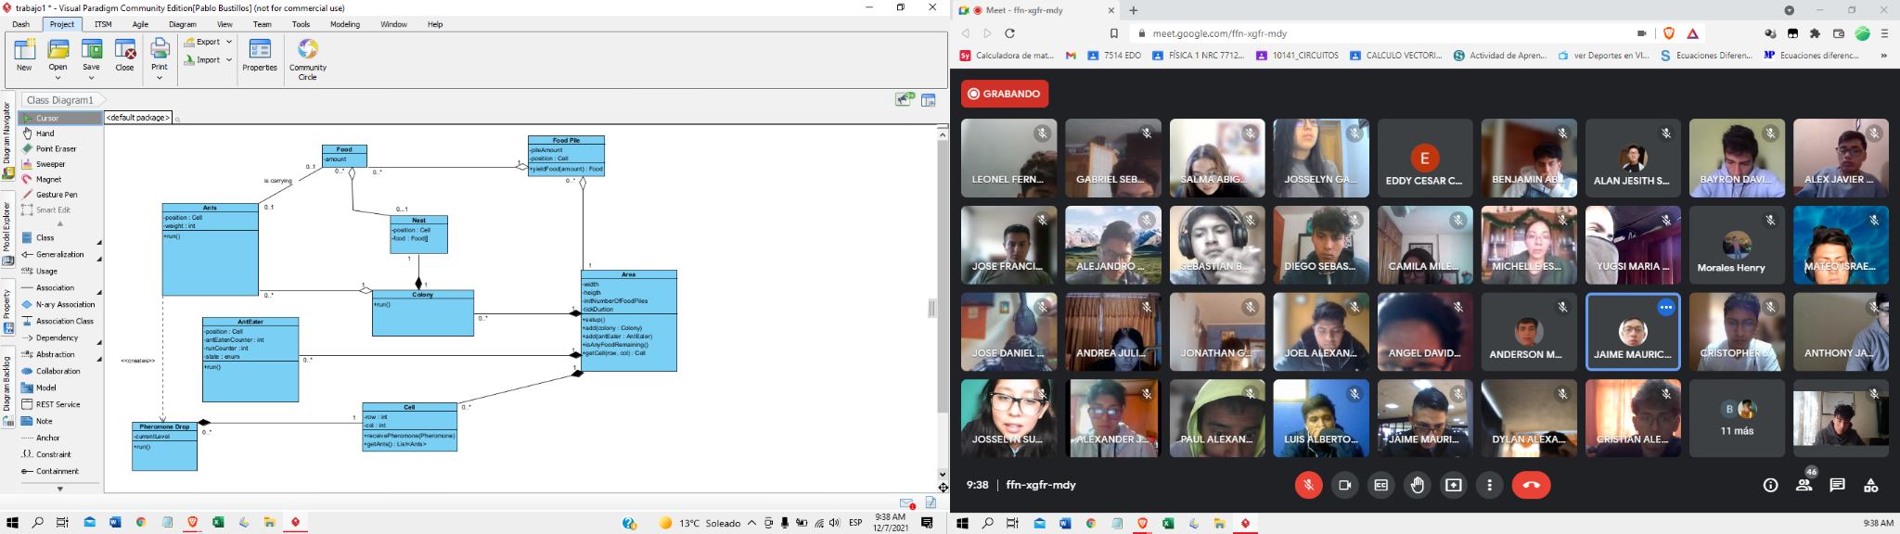

11 CADENA ROMAN BENJAMIN ABEL

Inspector: Sebastián Caisatoa

Clases: 9 /10 (simulator class is missing it only has 9 classes, pheromone class is pheremonedrop)

Relationships: 8 /10

1. Colony-Ant 1/1
2. Area-AntEater 1 /1
3. Area-Cell 0/1(there is no connection of area and cell)
4. Colony-Nest 1/1
5. FoodPile-Food 1/1
6. Ant-Food 1/1
7. Cell-PheromoneDrop 1/1
8. Area-Colony 1/1
9. Area-FoodPile 0/1 (there is no connection between area and FoofPile)
10. Simulator-Area 0/1 (simulator class is missing)
11. Ant-Pheromone 1/1

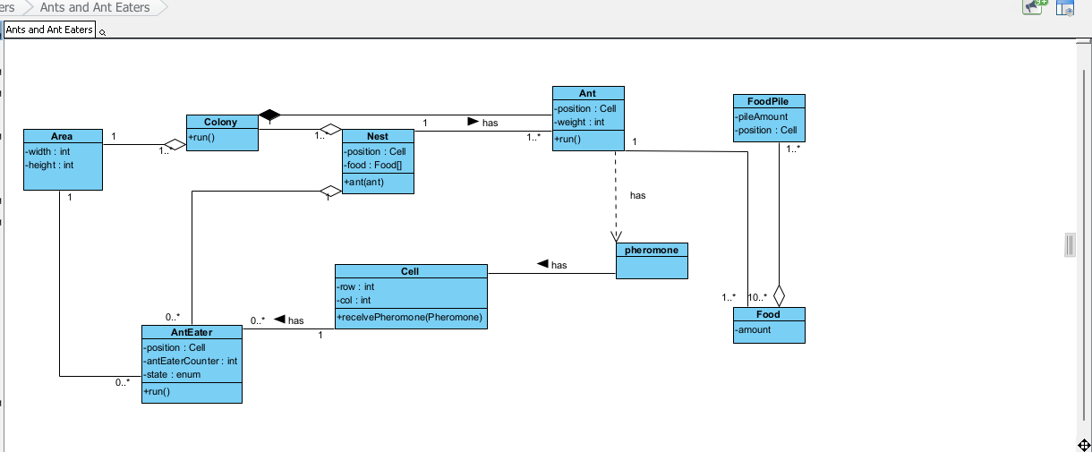

12 CAISATOA RAMIREZ SEBASTIAN BERNARDO

Inspector: Andy Calderón

classes: 9/10

relationships: 9/10

Colony-ant 1/1

Area- AntEater 1/1 (cell-AntEater)

Colony-Nest 1/1

FoodPile-Food 1/1

Ant- Food 1/1

Cell- PheromoneDrop 1/1

Area - Colony 1/1

Area - FoodPile 1/1

Simulator - Area 0/1

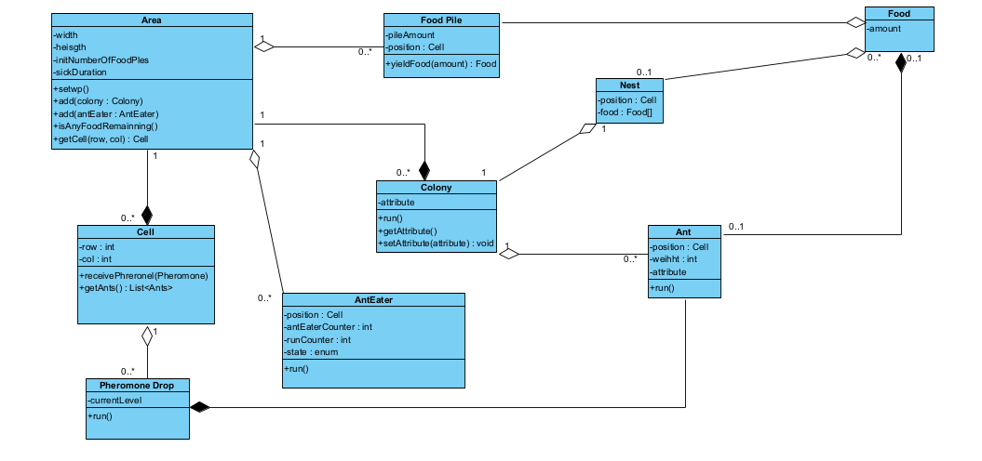

13 CALDERON MERCHAN ANDY JOSUE

Inspector:Correa Kerly

classes: 8/10 +1(Time class)

9/10

missing classes

* main class
* Food Pile class

relationships: 7/10

1. Colony-Ant 1 /1
2. Area-AntEater 0.5/1 (Cell-AntEater)
3. Area-Cell 0.5/1
4. Colony-Nest 0.5/1
5. Food-FoodPile 0 /1
6. Ant-Food 1/1
7. Cell-PheromoneDrop 0.5/1
8. Area-Colony 1/1
9. Area-FoodPile 0/1
10. Simulator-Area 1/1
11. Ant-Pheromone 1/1 (dependency)

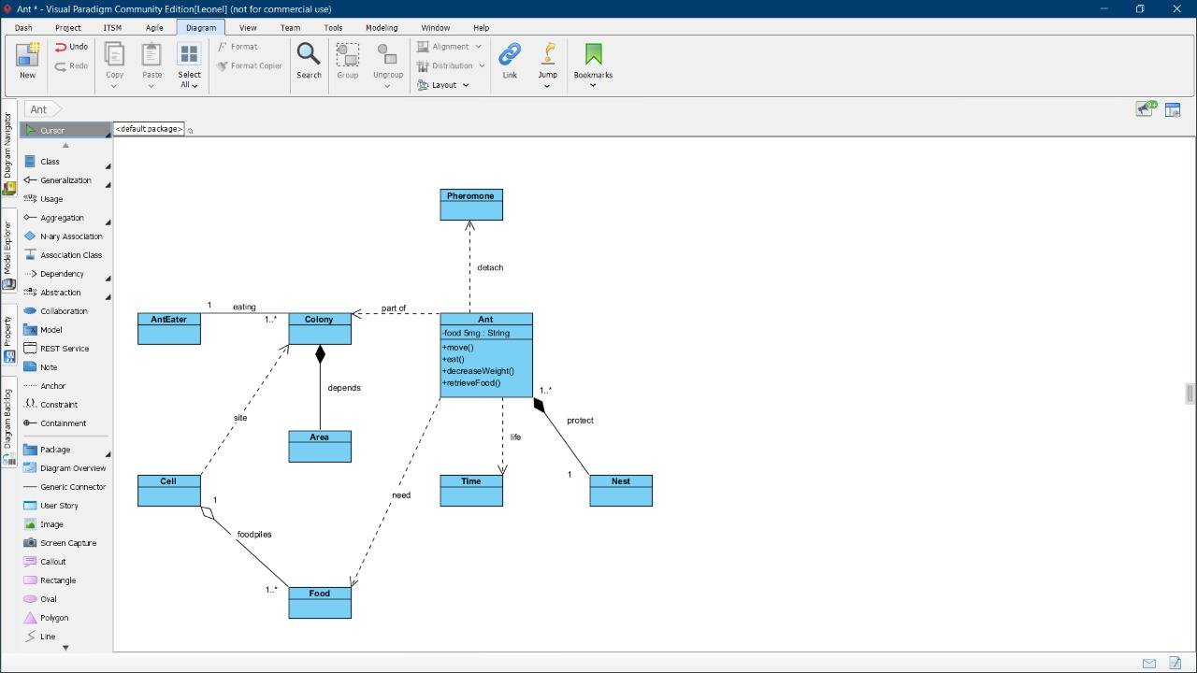

14 CORREA RUIZ KERLY YADIRA

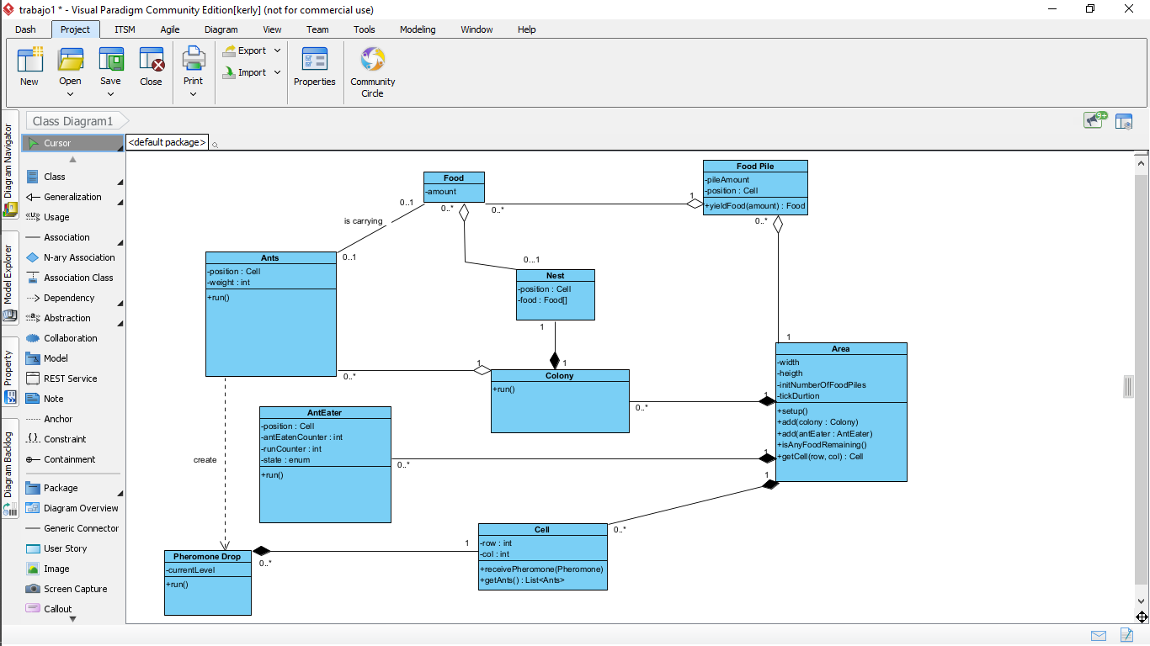

Inspector: Cruz Darling

classes: 9.5/10 Ants is in plural

relationships: 9.5/10

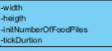 falta int

1. Colony-Ant 1/1
2. Area-AntEater 1/1 (Cell-AntEater)
3. Area-Cell 1/1
4. Colony-Nest 0.5/1 (upside down)
5. FoodPile-Food 0.5/1 (upside down)
6. Ant-Food 1/1
7. Cell-PheromoneDrop 1/1 (upside down)
8. Area-Colony 1/1
9. Area-FoodPile 0.5/1 (upside down)
10. Simulator-Area 1/1
11. Ant-Pheromone 1/1 (dependency)

TOTAL 9.5/11

15 CRUZ PANTOJA DARLING MICAELA

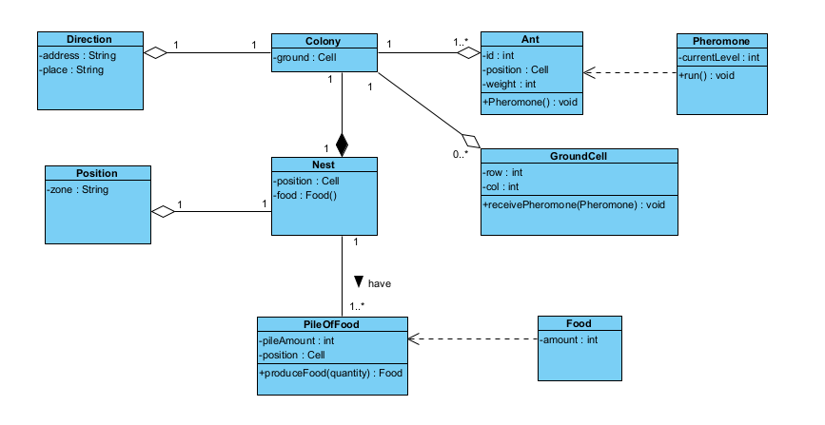  
Inspector: De La Cruz Alejandro

classes: 9/10 (falta una clase )

relationships: 8/10

Colony-Ant 1/1

Area-AntEater 1/1 (Cell-AntEater)

Area-Cell 1/1

Colony-Nest 1/1

FoodPile-Food 1/1

Ant-Food 0/1

Cell-PheromoneDrop 1/1

Area-Colony 1/1

Area-FoodPile 0/1

Simulator-Area 1/1

16 DE LA CRUZ QUINGA ALEJANDRO SEBASTIAN

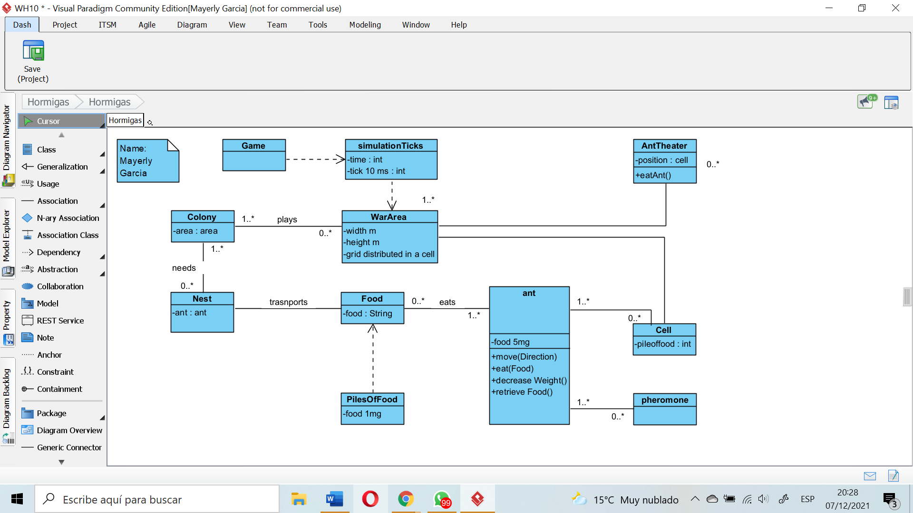

Inspector: Eivar Dagua

classes: 9/10 (lowercase in class (capitalized)) in ant-phermone

relationships: 9/10

Colony-Ant 1/1

Area-AntEater 1/1 (Cell-AntEater)

Area-Cell 0/1

Colony-Nest 1/1

FoodPile-Food 0/1

Ant-Food 1/1

Cell-PheromoneDrop 1/1

Area-Colony 1/1

Area-FoodPile 1/1

Simulator-Area 1/1

17 EIVAR DAGUA JAIME MAURICIO



Inspector: Mayerly Garcia

classes: 9/10 (pheromone, area, ground, nest, food, the first letter should be in capital letters)

relationships: 8/10

Colony- Ant 1/1

Area -AntEater 1/1

Area-Cell 1/1

Colony-Nest 1/1

FoodPile-Food 1/1

Ant-Food 1/1

Cell-PheromoneDrop 1/1

Area-Colony 0/1

Area-FoodPile 0/1

Game-Area 0/1

18 GARCIA BARRETO MAYERLY PRISSILLA

Inspector: Melissa Gómez

classes: 8/10 +1 (Ant and Pheromone are in lower case)

relationships: 9/10

1. Colony-Ant 0/1
2. Area-AntEater 1/1 (Cell-AntEater)
3. Area-Cell 1/1
4. Colony-Nest 1/1
5. FoodPile-Food 1/1
6. Ant-Food 0/1
7. Cell-PheromoneDrop 0/1
8. Area-Colony 1/1
9. Area-FoodPile 1/1
10. Simulator-Area 1/1
11. Ant-Pheromone 1/1 dependency



19 GOMEZ DIAZ MELISSA MALAYCA  
  
Inspector: Angel Guaman

Clases: 9/10 +1 (two classes are in lowercase)(eat)(phoro)

Relationships: 8.5/10

1. Colony-Ant 1/1
2. Area-AntEater 1/1
3. Area-Cell 0.5/1
4. Colony-Nest 1/1
5. FoodPile-Food 0.5/1
6. Ant-Food 0.5/1
7. Cell-PheromoneDrop 1/1
8. Area-Colony 1/1
9. Area-FoodPile 0.5/1
10. Simulator-Area 1/1

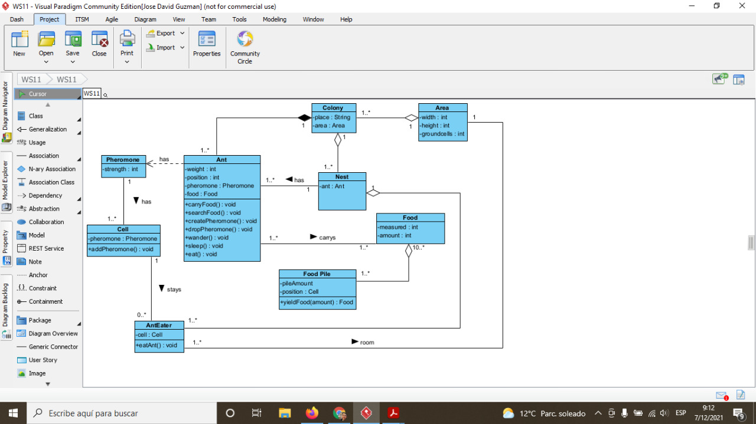

20 GUAMAN VEJARANO ANGEL DAVID

Inspector: Jhon Guitarra

Clases: 9/10

missing ( main class)

There aren't the class Simulador Display

Relationships: 7.5/10

1. Colony-Ant 1/1

2. Area-AntEater 1/1

3. Area-Cell 0.5/1 Wrong Way

4. Colony-Nest 1/1

5. Food Pile-Food 0.5/1 Wrong Way

6. Ant-Food 0.5/1 Wrong Way

7. Cell-Pheromone Drop 1/1

8. Area-Colony 1/1

9. Area-Food Pile 1/1

10. Simulator-Area 0/1 missing (main )

11. Ant-Pheromone 0/1 dependency



21 GUITARRA SANCHEZ JHON ALEXANDER  
Inspector: Jose Guzman

Clases: 7/10 +1 (Classes Direction and Position)

There aren't the classes main, area, and anteater

Colony-Ant 0.5/1 (The relation colony and ant it is backward)

Area-AntEater 0/1 (There aren't the relationship)

Area-Cell 0/1 (There aren't the relationship)

Colony-Nest 1/1

FoodPile-Food 1/1

Ant-Food 0/1 (There aren't the relationship)

Cell-PheromoneDrop 0/1 (There aren't the relationship)

Area-Colony 1/1

Area-Foodpile 0/1 (There aren't the relationship)

Main-Area 0/1 (There aren't the relationship)

Ant-Pheromone 1/1

Relationships: 4.5/10

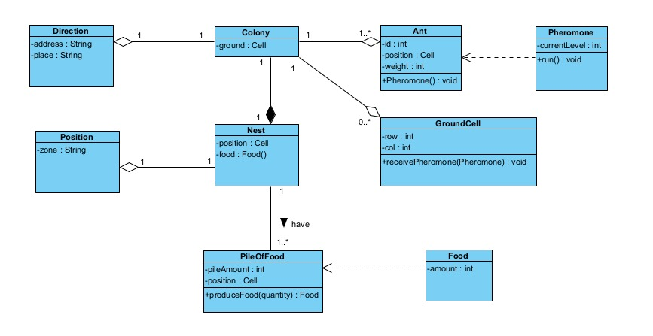

22 GUZMAN LOPEZ JOSE DAVID

Inspector: Jonathan Insuasti

Classes= 9 /10

doesn´t exist main class

Relationships= 8 /10

1. Colony-Ant 1/1
2. Area-AntEater 1/1 (Cell-AntEater)
3. Area-Cell 1/1
4. Colony-Nest 1/1
5. FoodPile-Food 1/1
6. Ant-Food 1/1
7. Cell-PheromoneDrop 1/1
8. Area-Colony 1/1
9. Area-FoodPile 0/1
10. Simulator-Area 0/1

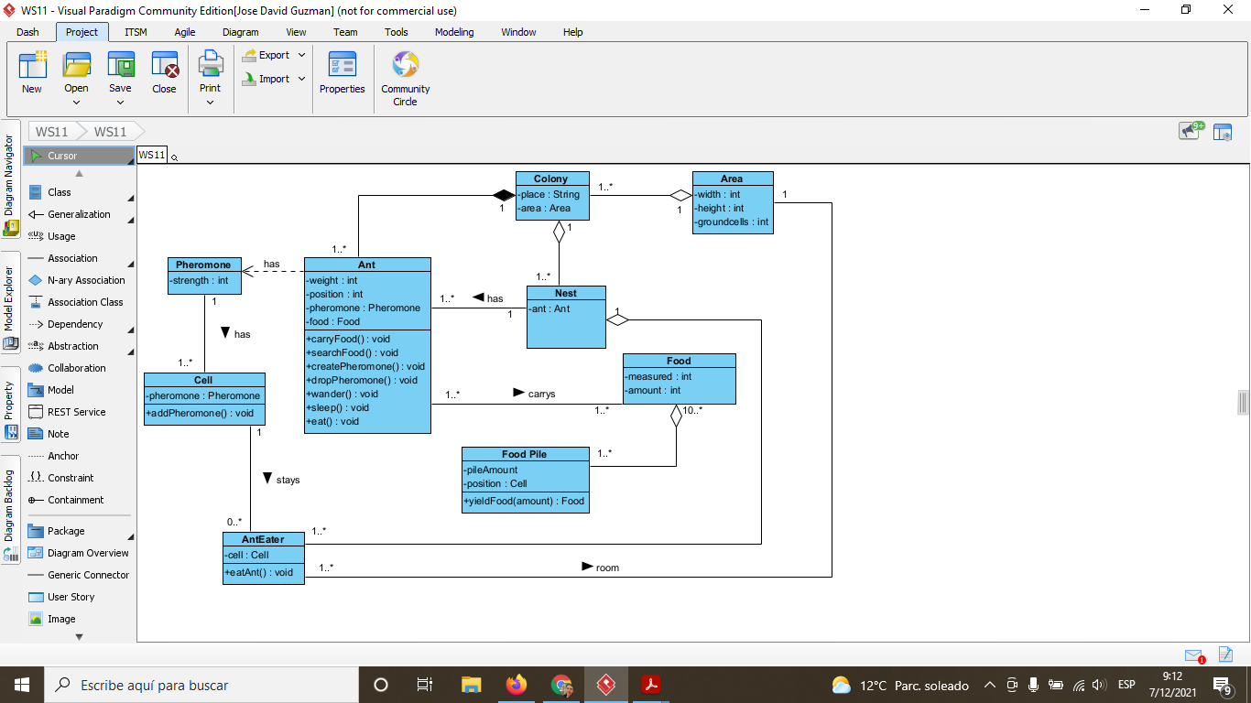

23 INSUASTI LOPEZ JONATHAN ESTEBA

Inspector: Mateo Landázuri

classes:9/10 Missing class main(display simulator,change name class Area por Ant)

relationships: 7/10

1. Colony-Ant 1/1
2. Area-AntEater 1/1 (Cell-AntEater)
3. Area-Cell 0/1
4. Colony-Nest 1/1
5. FoodPile-Food 1/1
6. Ant-Food 0/1
7. Cell-PheromoneDrop 1/1
8. Area-Colony 1/1
9. Area-FoodPile 1/1
10. Simulator-Area 0/1

Total: 16



24 LANDAZURI SEGOVIA MATEO ISRAEL

Inspector: Daniel Lincango

clases:9/10 missing classes (Food pite-Simulator Display)

relationships:6/10

1. Colony-Ant 1/1
2. Area-AntEater 0/1
3. Area-Cell 1/1
4. Colony-Nest 0/1
5. FoodPile-Food 1/1
6. Ant-Food 1/1
7. Cell-PheromoneDrop 1/1
8. Area-Colony 1/1
9. Area-FoodPile 0/1
10. Simulator-Area 0/1

Total:15



25 LINCANGO CRIOLLO JOSE DANIEL

Inspector: Maisincho Richar

clases: 8.5/10 missing classes simulator display,pheromone drop

relationship:7/10

1. Colony-Ant 1/1
2. Area-AntEater 1/1
3. Area-Cell 1/1
4. Colony-Nest 1/1
5. FoodPile-Food 1/1
6. Ant-Food 1/1
7. Cell-PheromoneDrop 0/1
8. Area-Colony 1/1
9. Area-FoodPile 0/1
10. Simulator-Area 0/1

total 15.5

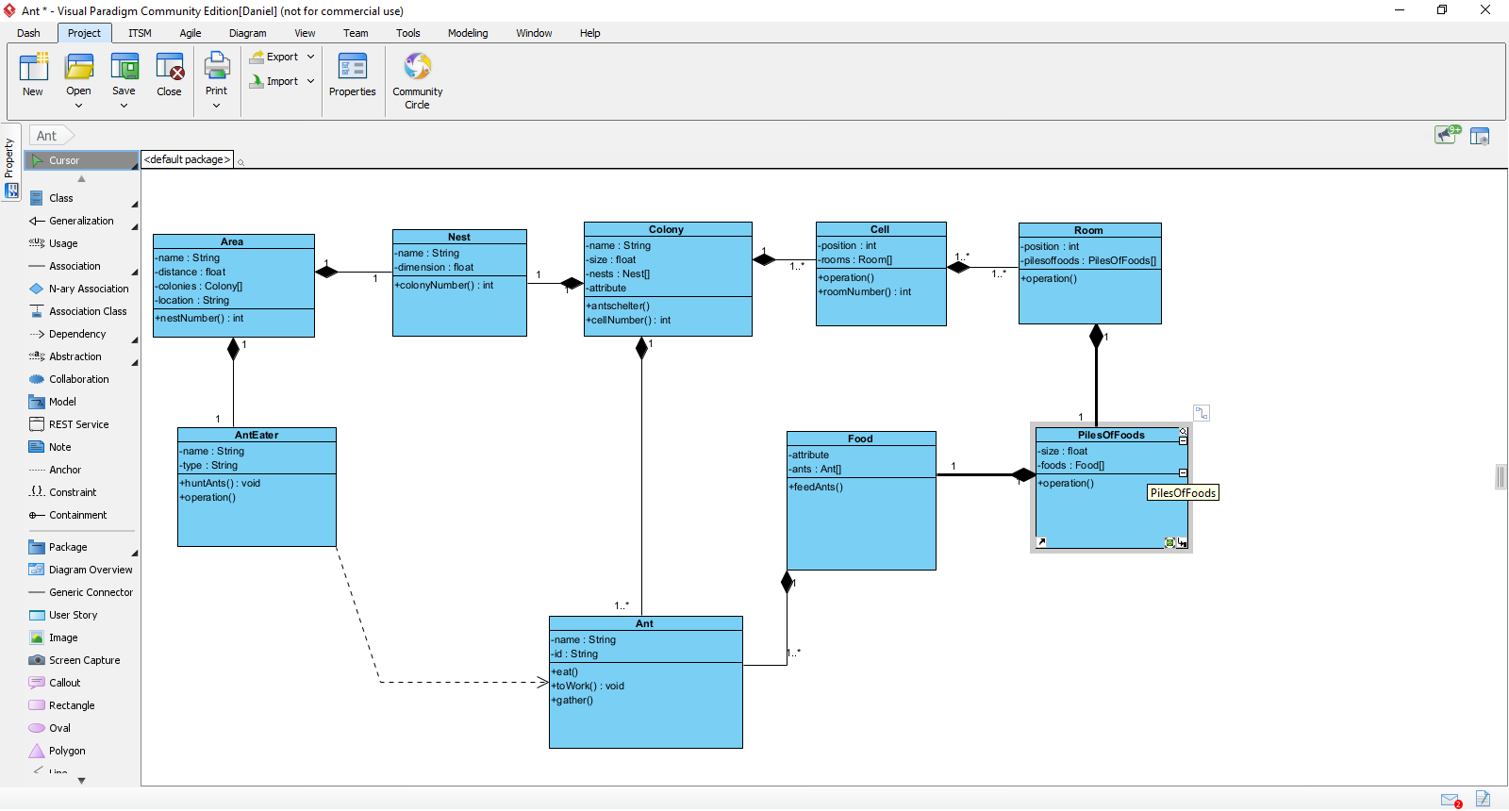

26 MAISINCHO PAUCAR RICHAR ALEXANDER

Inspector: Maldonado Mateo

classes: 9/10 Missing Food Pile, Simulator Display

relationships: 3/10 +

Colony-Ant 1/1

Area-AntEater 0/1

Area-Cell 0/1

Colony-Nest 0/1

FoodPile-Food 0/1

Ant-Food 1/1

Cell-PheromoneDrop 0/1

Area-Colony 1/1

Area-FoodPile 0/1

Simulator-Area 0/1



27 MALDONADO BASTIDAS MATEO STEFANO

Inspector: Leonel Mantuano

classes: 8/10(FoodPile,nest, simulator display)

relationships: 6 /10 +1

1. Colony-Ant 1/1
2. Area-AntEater 1/1
3. Area-Cell 1/1
4. Colony-Nest 0/1
5. Foodpile-Food 0/1
6. Ant-Food 1/1
7. Cell-PheromoneDrop 1/1
8. Area-Colony 1 /1
9. Area-FoodPile 0/1
10. Simulator-Area 0/1
11. Ant-Pheromone 1/1

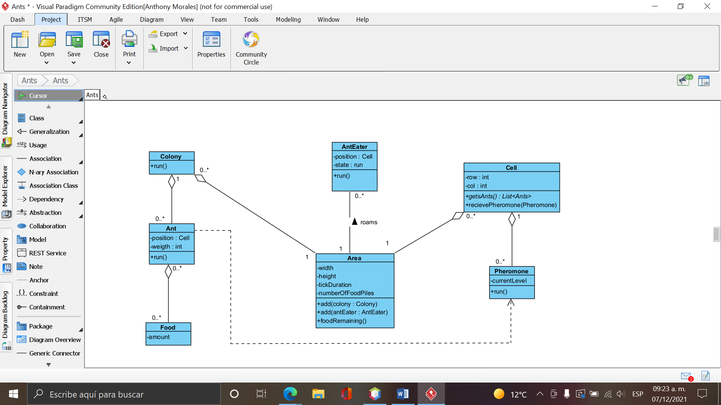

28 MANTUANO FERNANDEZ LEONEL FERNANDO

Inspector: Anthony Morales

classes: 8/10 missing class (simulator display, food pile) and missing attributes and methods

relationships: 3/10

TOTAL: 11/20

1. Colony-Ant 1/1
2. Area-AntEater 0/1
3. Area-Cell 0/1
4. Colony-Nest 0/1
5. Food-Pile 0/1
6. Ant-Food 1/1
7. Cell-Pheromone 0/1
8. Area-Colony 1/1
9. Area-FoodPile 0/1
10. Simulator-Area 0/1



29 MORALES CAICEDO ANTHONY JAVIER

Inspector: Sebastian Palacios

classes: 8/10 Missing class(Nest, Simulator display, Foodpile)

relationships: 7/10

1. Colony-Ant: 1/1
2. Area-AntEater: 1/1
3. Area-Cell: 1/1
4. Colony-Nest: 0/1
5. FoodPile-Food: 0/1
6. And-Food: 1/1
7. Cell-PhermoneDrop: 1/1
8. Area-Colony: 1/1
9. Area- FoodPile: 0/1
10. Simulator-Area: 0/1
11. Ant-Pheromone:1/1

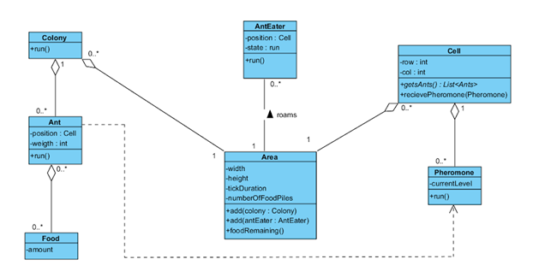

30 PALACIOS CANDO DIEGO SEBASTIAN

Inspector: Javier Paucar

Classes: 7/10 Missing classes (Nest,Simulator Display,FoodPile)

Relationships: 7/10

1. Colony-Ant: 1/1
2. Area-AntEater: 1/1
3. Area-Cell: 1/1
4. Colony-Nest : 0/1
5. FoodPile-Food: 0/1
6. Ant-Food: 1/1
7. Cell-PheromoneDrop: 1/1
8. Area-Colony: 1/1
9. Area-FoodPile: 0/1
10. Simulator-Area: 0/1
11. Ant-Pheromone: 1/1



31 PAUCAR LEMA ALEX JAVIER

Inspector: Quinga Leandro

classes: 8/10 Missing classes main (Simulator Display and Food Pile )

relationships: 8/10

1. Colony-Ant: 1/1
2. Area-AntEater: 1/1
3. Area-Cell: 1/1
4. Colony-Nest: 1/1
5. FoodPile-Food: 1/1
6. Ant-Food: 1/1
7. Cell-PheromoneDrop: 1/1
8. Area-Colony: 1/1
9. Area-FoodPile: 0/1
10. Simulator-Area: 0/1



32 QUINGA GUAYASAMIN LEANDRO ALEXANDER

Inspector: Ruano Alexander

classes: 9/10 Missing classes main( Simulator Display)

relationships: 7/10

Colony-Ant 1/1

Area-AntEater 1/1 (Cell-AntEater)

Area-Cell 0/1

Colony-Nest 1/1

FoodPile-Food 1/1

Ant-Food 1/1

Cell-PheromoneDrop 0/1

Area-Colony 1/1

Area-FoodPile 0/1

Simulator-Area 0/1



33 RUANO PONCE ALEXANDER JAVIER

Inspector: Saltos Taco Paul Alexander

classes: 9/10 Class simulator display is missing

relationships: 8/10

1. Colony-Ant 1/1
2. Area-AntEater 1/1
3. Area-Cell 1/1
4. Colony-Nest 1/1
5. FoodPile-Food 1/1
6. Ant-Food 1/1
7. Cell-PheromoneDrop 0/1
8. Area-Colony 1/1
9. Area-FoodPile 1/1
10. Simulator-Area 0/1
11. Ant-Pheromone 0/1



34 SALTOS TACO PAUL ALEXANDER

Inspector: Sánchez Mishquero José Franciso

classes: 8/10 missing food pile

relationships: 8/10

Colony-Ant 1/1

Area-AntEater 1/1

Area-Cell 1/1

Colony-Nest 1/1

FoodPile-Food 1/1

Ant-Food 1/1

Cell-PheromoneDrop 1/1

Area-Colony 1/1

Area-FoodPile 0/1

Simulator-Area 0/1

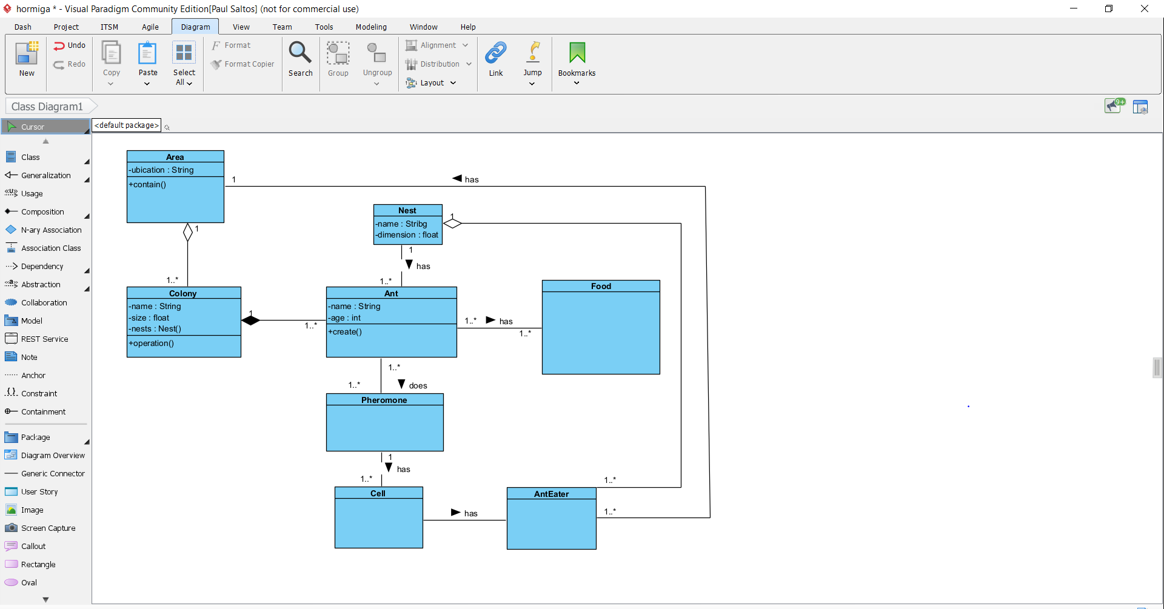

35 SANCHEZ MISHQUERO JOSE FRANCISCO

inspector:Shuguli Alan

classes: 8/10 missing class (simulador display) ,lowercase class name(pheromone,area,nest,ground)

relationships: 9/10

Colony-Ant 1/1

Area-AntEater 1/1 (Cell-AntEater)

Area-Cell 1/1

Colony-Nest 1/1

FoodPile-Food 1/1

Ant-Food 1/1

Cell-PheromoneDrop 1/1

Area-Colony 1/1

Area-FoodPile 1/1

Simulator-Area 0/1

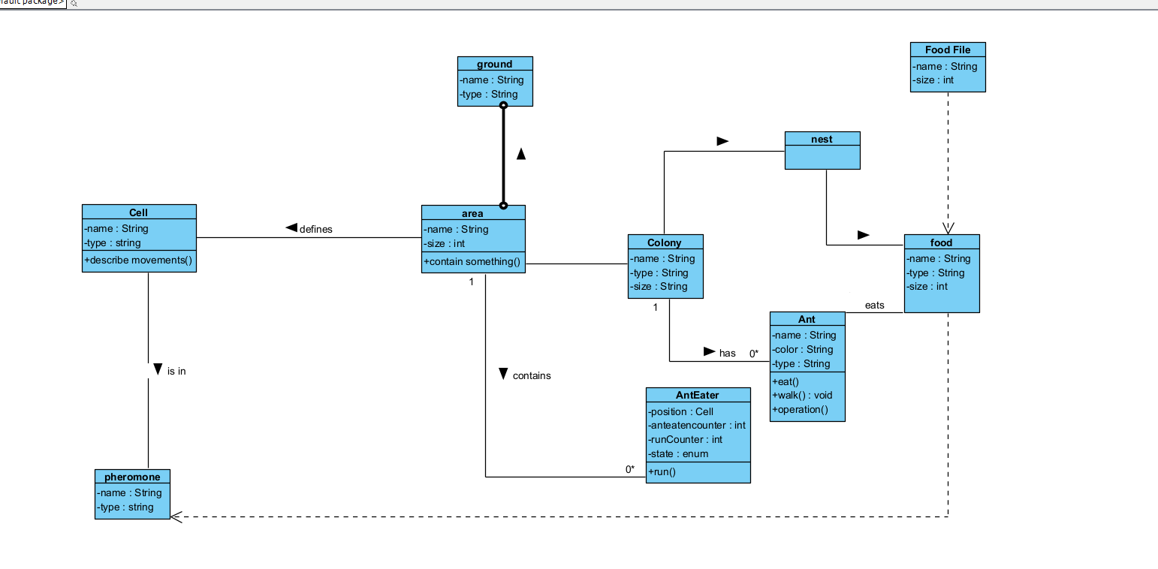

36 SHUGULI REINOSO ALAN JESITH

Inspector: Gustavo Simbaña

classes:: 8.5/10 ( Ant and Pheromone lowercase) (AntEater)

relationships 6/10

1 Colony-Ant 0/1

2 Area-AntEater 0/1

3 Area-Cell 1/1

4 Colony- Nest 1/1

5 FoodPile-Food 1/1

6 And-Food 1/1

7 Cell-PheromoneDrop 0/1

8 Area-Colony 1/1

9 Area-FoodPile 0/1

10 Simulator-Area 1/1

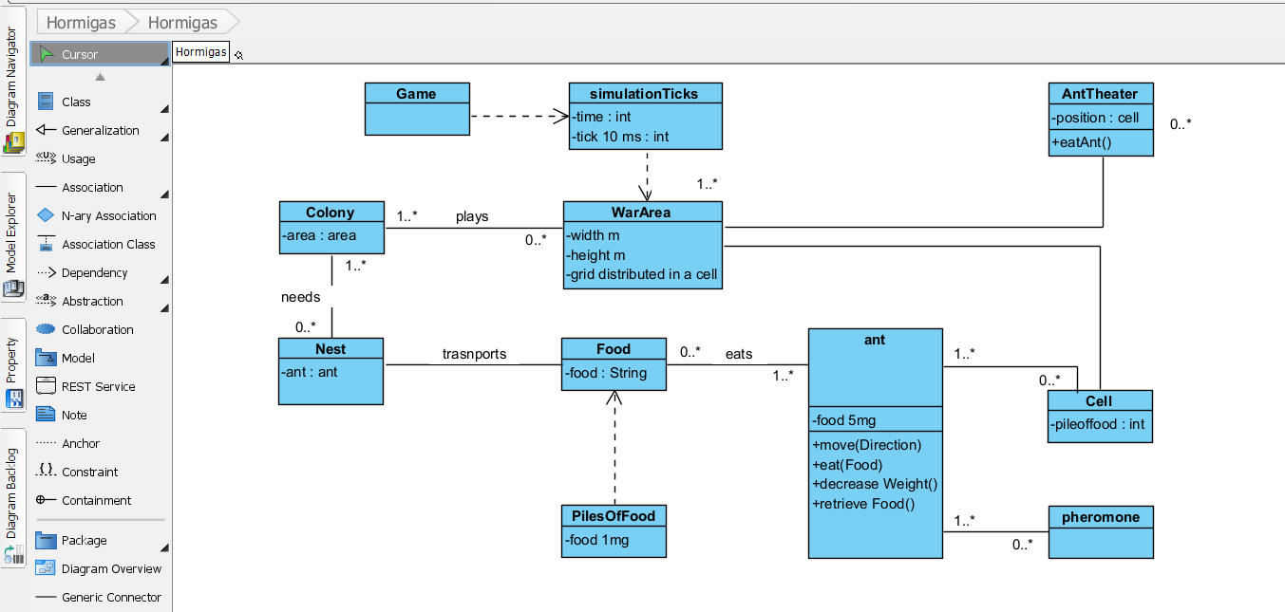

37 SIMBAÑA SIMBAÑA JONATHAN GUSTAVO

Inspector: Andrea Tapia

relationships: 8/10

classes: 9.5/10 Tick not a good class

1. Colony-Ant 1/1
2. Area-AntEater 0.5 /1
3. Area-Cell 1/1
4. Colony-Nest 1/1
5. FoodPile-Food 1/1
6. Ant-Food 0.5/1
7. Cell-Pheromone 1/1
8. Area-Colony 1/1
9. Area- FoodPile 1/1
10. Simulator-Area 0/1

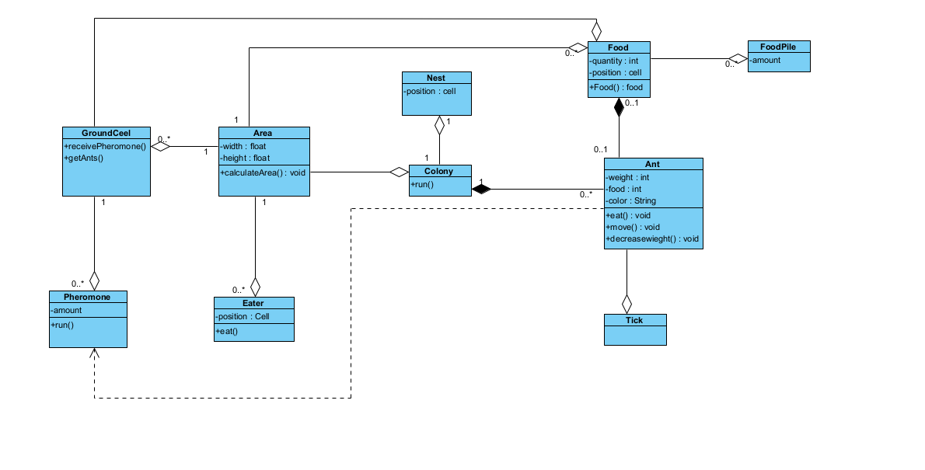

38 TAPIA ALBAN ANDREA JULIANNA

Inspector: Sebastian Tayo

Inspector:

classes: 9.5/10

relationships: 9/10

1. Colony-Ant 0.5/1(backwards)
2. Area-AntEater 1/1
3. Area-Cell 1/1
4. Colony-nest 1/1
5. FoodPile-Food 1/1
6. Ant-Food 0.5/1(backwards)
7. Cell-PheromoneDrop 1 /1
8. Area-Colony 1 /1
9. Area-FoodPile 1/1
10. Simulator-Area 1/1

There are 10 classes but, remember tick is not a good class.

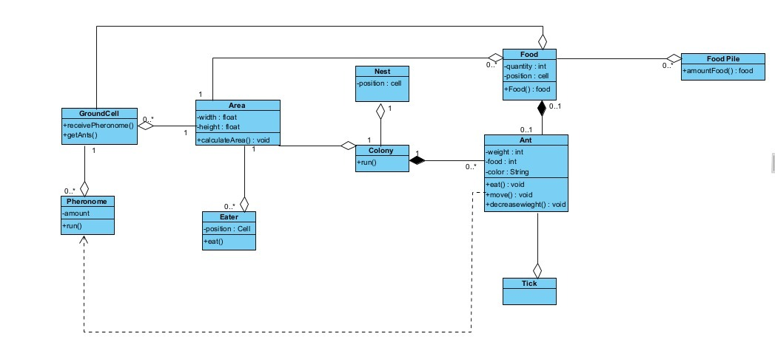

39 TAYO RUIZ SEBASTIAN ALEJANDRO

Inspector: Camila Teca

classes: 10/10

relationships: 8.5/10

**TOTAL**: 18.5/20

1. Colony-Ant 1/1
2. Area-AntEater 1/1
3. Area-Cell 0.5/1 (it's backwards)
4. Colony-Nest 1/1
5. FoodPile - Food 0.5/1 (missing multiplicity)
6. Ant-Food 1/1
7. Cell-PheromoneDrop 1/1
8. Area-Colony 0.5 /1 (it's backwards)
9. Area-FoodPile 1/1
10. Simulator-Area 1 /1

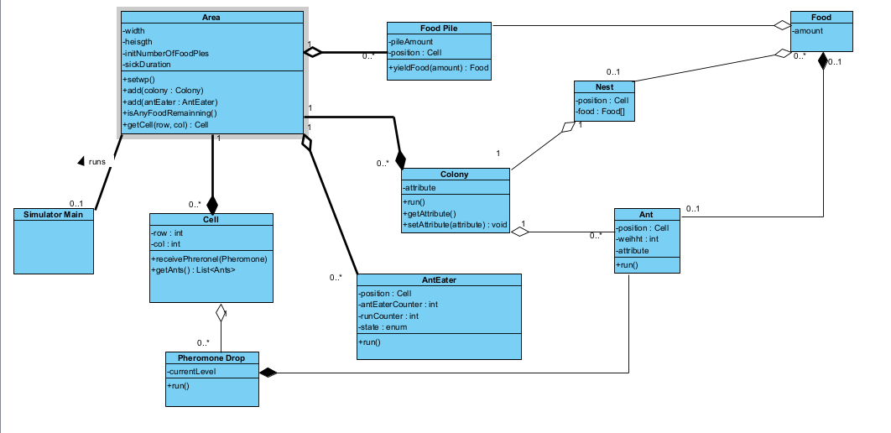

40 TECA TELLO CAMILA MILENA

**Inspector**: Melanie Terán

**classes**: 9/10 Missing Class: Simulator Display

-change PheromoneDrop, AntEater, FoodPile,Colony

1. Colony-Ant 1/1
2. Area-AntEater 1/1 (Cell-AntEater)
3. Area-Cell 0/1
4. Colony-Nest 0/1
5. FoodPile-Food 1/1
6. Ant-Food 1/1
7. Cell-PheromoneDrop 1/1
8. Area-Colony 1/1
9. Area-FoodPile 0/1
10. Simulator-Area 0/1

+Ant-Pheromone 1/1 dependency

**relationships**: 7/10

Total: 16/20

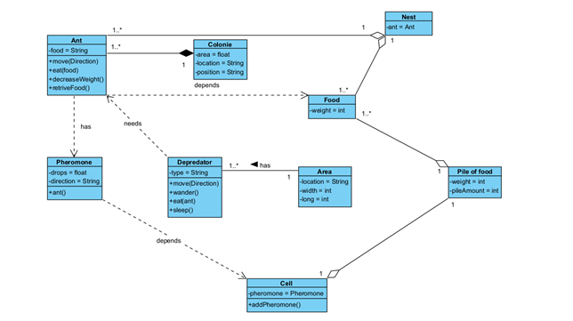

**41 TERAN FLORES MELANIE ELIZABETH**

**Inspector: Salma Villegas**

**Classes:** 9/10

Missing classes: Simulator Display, Food Pile

The names are okey

**Relationships:**  7/10

Colony-Ant 1/1

Area-AntEater 1/1 (Cell-AntEater)

Area-Cell 0/1

Colony-Nest 1/1

FoodPile-Food 0/1

Ant-Food 1/1

Cell-PheromoneDrop 1/1

Area-Colony 1/1

Area-FoodPile 0/1

Simulator-Area 0/1

Ant-Pheromone 1/1 dependency

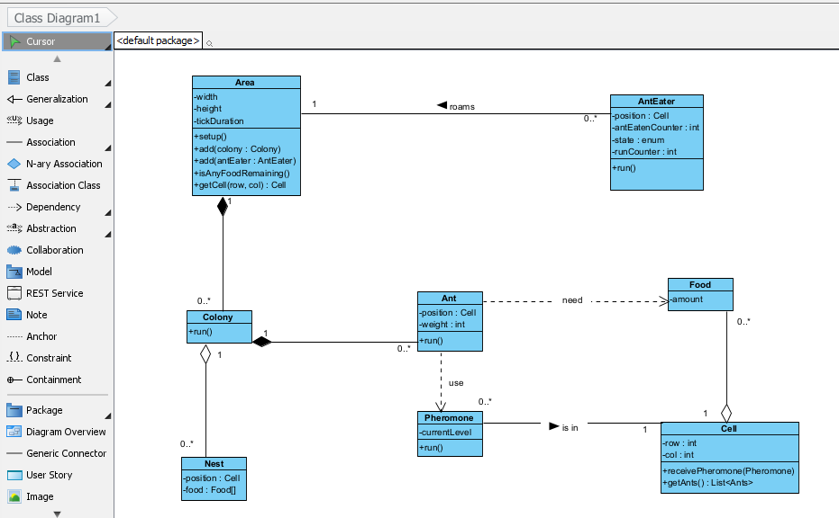

42 VILLEGAS ESTRELLA SALMA ABIGAIL

**Inspector: Joel Zeas**

**Classes:** 9/10 Change name (Pheromone Drop - AntEater - Food Pile) - Missing class “Simulator Display”

**Relationships**: 7/10

**Total points:**  16/20

1. Colony-Ant 1/1
2. Area-AntEater 1/1 (Cell-AntEater)
3. Area-Cell 0/1
4. Colony-Nest 0/1
5. FoodPile-Food 1/1
6. Ant-Food 1/1
7. Cell-PheromoneDrop 1/1
8. Area-Colony 1/1
9. Area-FoodPile 0/1
10. Simulator-Area 0/1
11. Ant-Pheromone 1/1 dependency



43 ZEAS CLAVIJO JOEL ALEXANDER

Inspector: Anderson Almache

Classes: 9/10 (Class is missing Simulator Display and change name of the some classes)

Relationships: 7/10

Total points: 16/20

1. Colony-Ant 1/1
2. Area-AntEater 1/1 (Cell-AntEater)
3. Area-Cell 0/1
4. Colony-Nest 0/1
5. FoodPile-Food 1/1
6. Ant-Food 1/1
7. Cell-PheromoneDrop 1/1
8. Area-Colony 1/1
9. Area-FoodPile 0/1
10. Simulator-Area 0/1
11. Ant-Pheromone 1/1 (dependency)

